Assignments for Lab 1: Tasks 1,2,3.

Task 1:

1. ER Diagram



1. Class Diagram



Task 2:

Github account created. Id: LaxmanDuttDegala

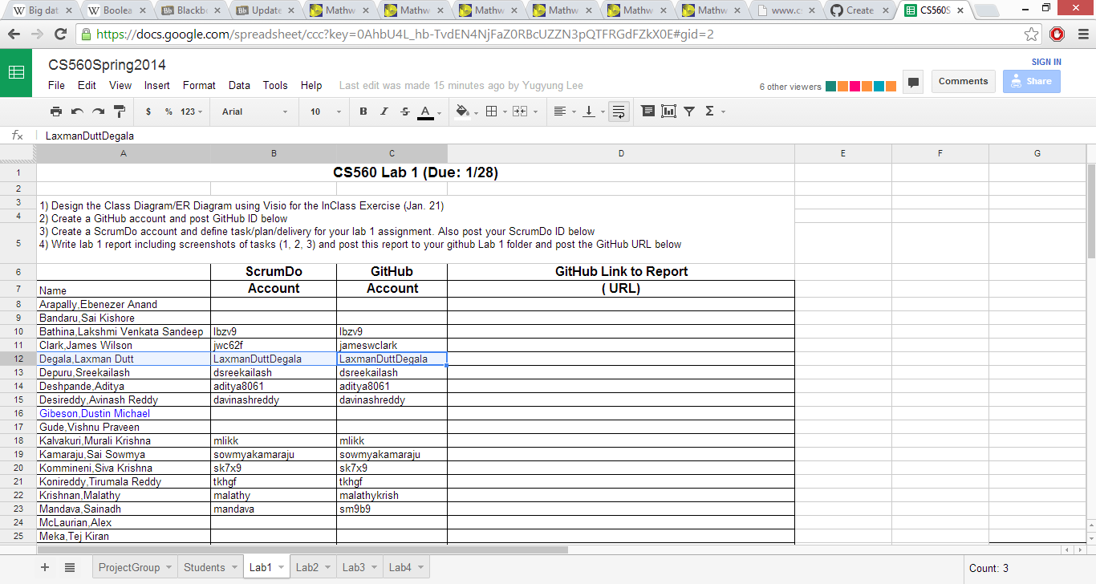

Task 3:

ScrumDo ID Created. Id: LaxmanDuttDegala

Link: <http://www.scrumdo.com/projects/project/cs5603/>

